Name: _______________________ LEK Mathematik - Klasse: 5c

Datum: 09. 02. 2021 Wiederhole die schriftliche Division mit Probe (= Multiplikationsaufgabe):
1. |  | 4 | 5 | 7 | 0 | 5 | : | 5 | =
 |  |  |  |  |  |  |  |  |  |  | P | r | o | b | e:

2. |  | 6 | 7 | 6 | 8 | 9 | 6 | : | 8 | =
 |  |  |  |  |  |  |  |  |  |  | P | r | o | b | e:
3. |  | 1 | 4 | 2 | 7 | 6 | 4 | : | 6 | =
 |  |  |  |  |  |  |  |  |  |  |  |  |  |  |  |  |  |  |  | 
 |  |  |  |  |  |  |  |  |  |  | P | r | o | b | e:
4. |  | 2 | 5 | 8 | 6 | 6 | 4 | : | 7 | =
 |  |  |  |  |  |  |  |  |  |  | P | r | o | b | e:
 |  |  |  |  |  |  |  |  |  |  |  |  |  |  |  |  |  | 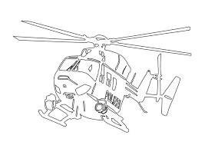

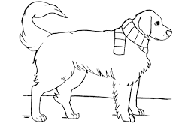

Z | u | s | a | t | z | a | u | f | g | a | b | e: |  |  |  |  |  | 
a)
 |  | 5 | 7 | 1 | 1 | 2 | 8 | 3 | : | 9 | =

b)
 |  | 2 | 7 | 2 | 8 | 7 | 7 | 6 | : | 8 | =
 |  |  |  |  |  |  |  |  |  |  |  |  |  |  |  | 

